SIMATS ENGINEERING
ASSESSMENT TOOL 2

COURSE NAME: MLA03
COURSE CODE: Reinforcement learning for Environment and Agent

COURSE OUTCOME COVERED

CO2: Apply Dynamic Programming methods to solve reinforcement learning problems and derive optimal policies for decision-making tasks. ( BL2, BL3)

Assessment Tool Weightage: 30%

Dr G.A. SENTHIL

QUESTIONS: 10 Total Marks: 50

Annexure A
Application - Based Questions
Duration: 2Hrs

1. Design and develop a Reinforcement Learning framework a ride-sharing company uses Reinforcement Learning to match drivers with passengers efficiently. Apply RL concepts to define the state space, action space, and reward function to minimize waiting time and improve service quality. (5 Marks)

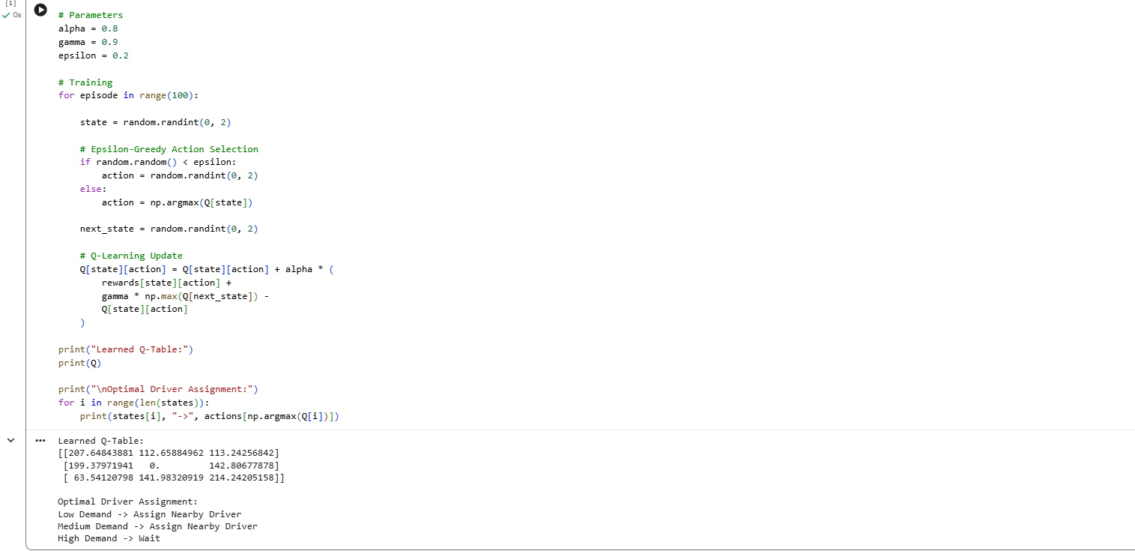

2. An e-learning platform uses Reinforcement Learning to recommend personalized study materials. Recall how exploration and exploitation strategies help balance familiar and new content recommendations. (5 Marks)

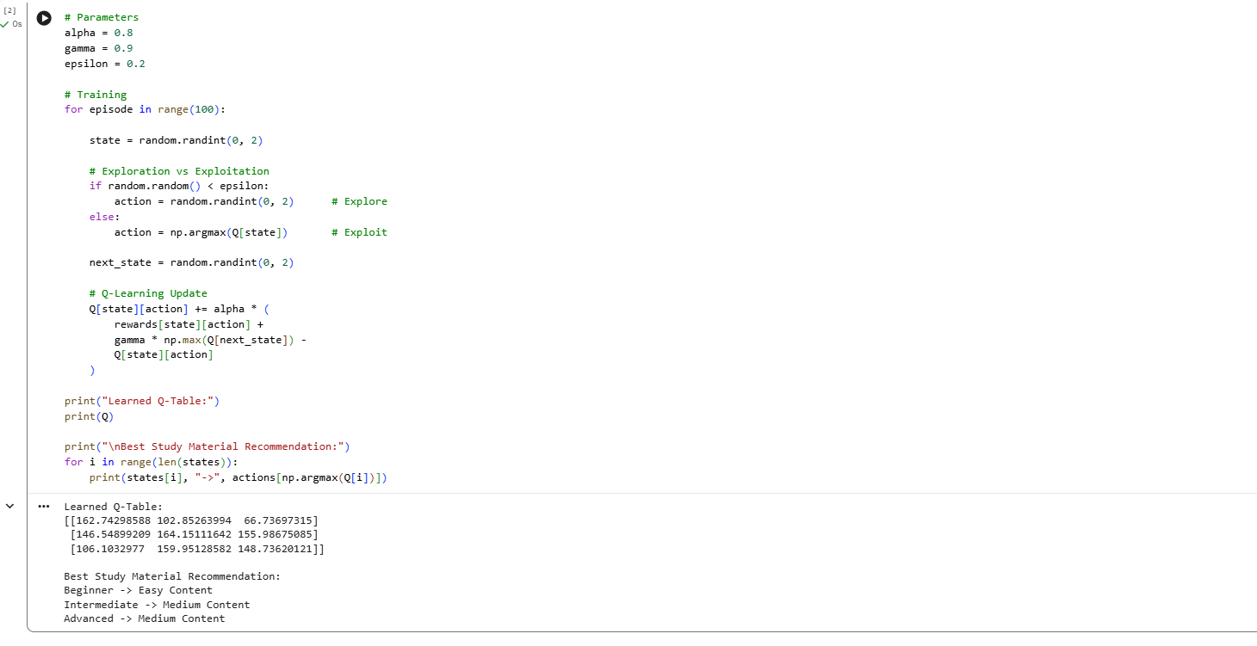

3. Design and develop a Reinforcement Learning framework a robotic vacuum cleaner uses Reinforcement Learning to clean efficiently while avoiding obstacles. Apply the concept of policy and explain how the value function improves performance over time.
(5 Marks)
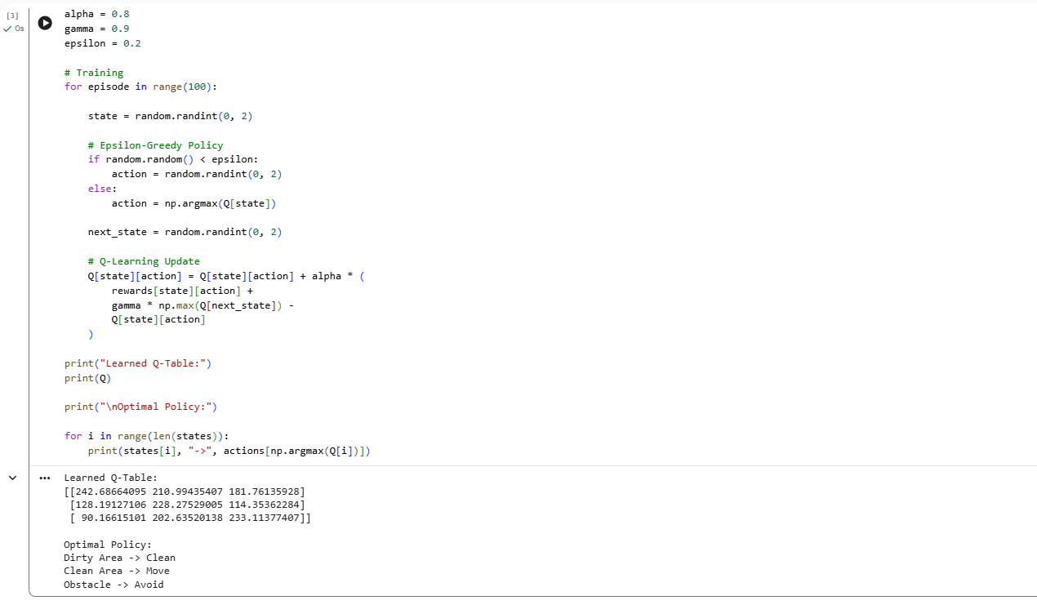

4. A cryptocurrency trading system uses Reinforcement Learning to decide buy, sell, or hold actions. Outline the challenges in designing reward functions and explain how poor reward design can affect performance. (5 Marks)
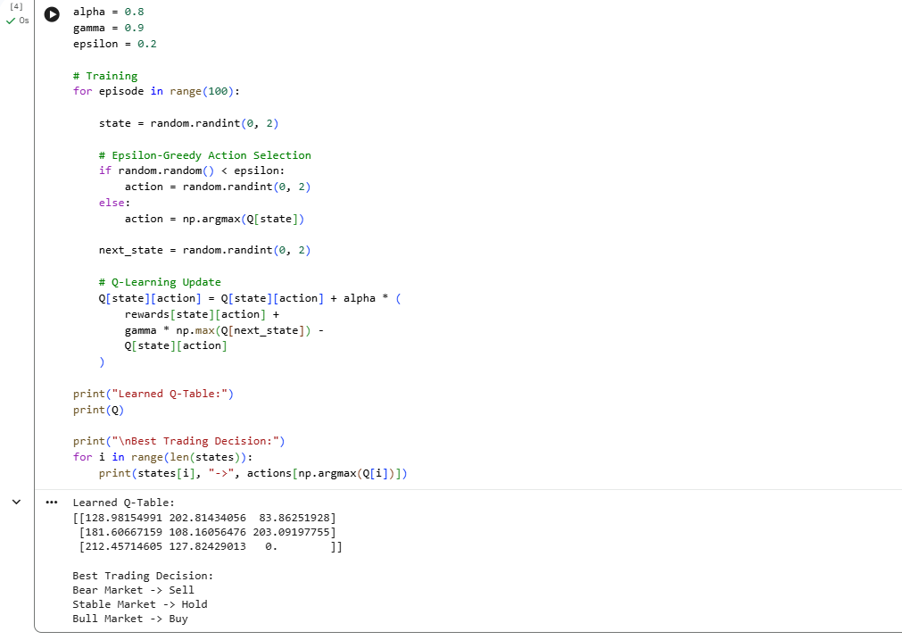

5. Develop a smart grid system uses Reinforcement Learning to manage electricity distribution. Create an RL model by defining state space, action space, and reward mechanism. (5 Marks)
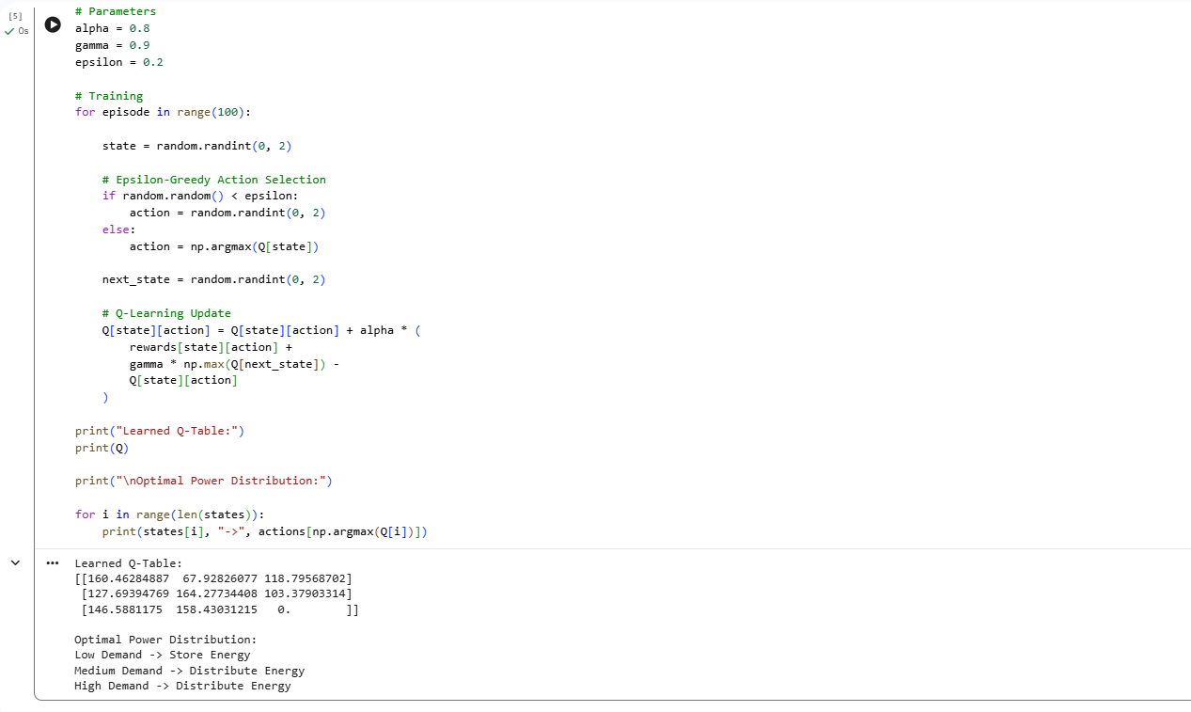

6. A healthcare monitoring system uses Reinforcement Learning to adjust medication dosages. Apply RL concepts to define states, actions, and rewards, and explain how learning improves outcomes. (5 Marks)
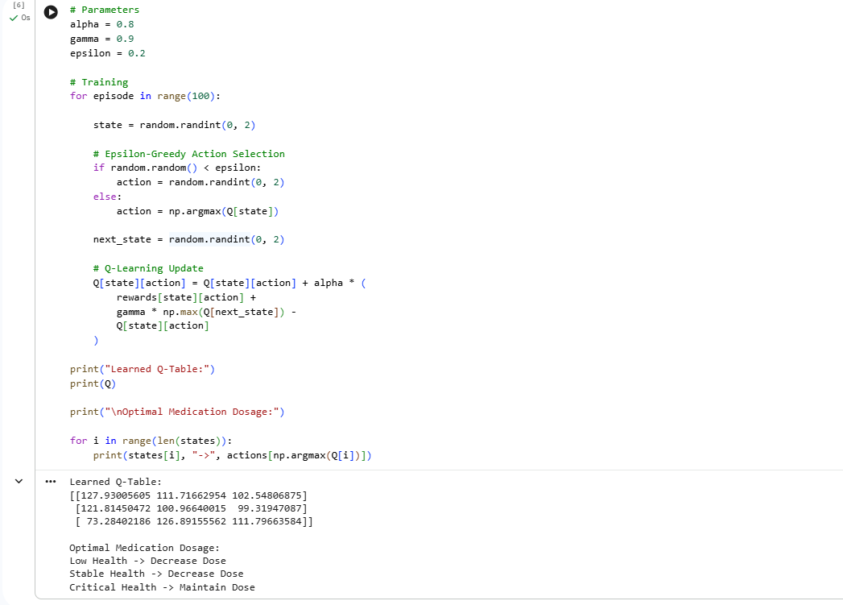

7. Design a model drone delivery system uses Reinforcement Learning for navigation. Recall how exploration and exploitation strategies influence route optimization.
(5 Marks)
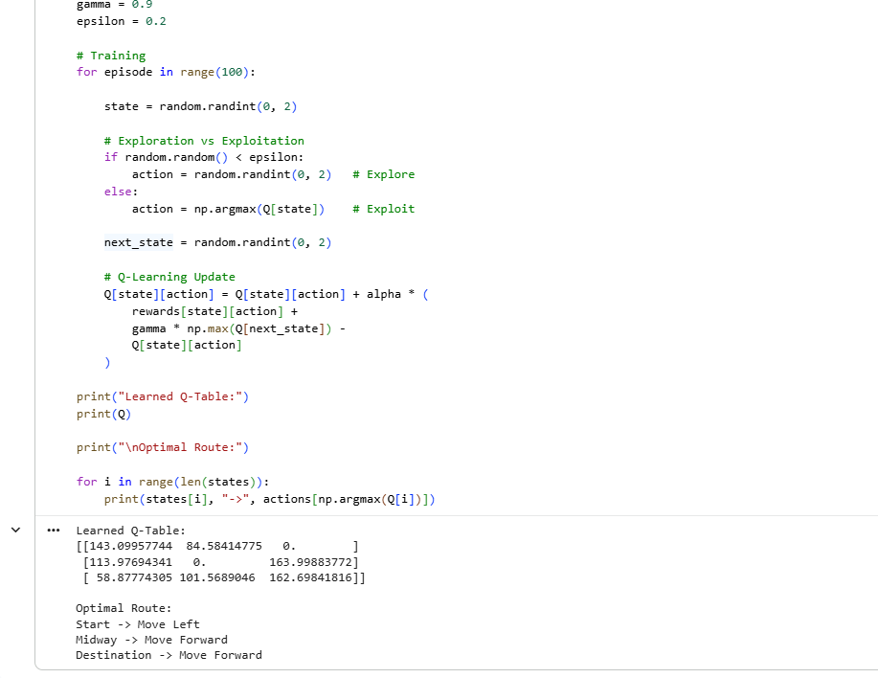
8. Design and develop a Reinforcement Learning framework a manufacturing robot uses Reinforcement Learning to optimize assembly operations. Apply the concept of policy and explain how value functions help improve efficiency. (5 Marks)
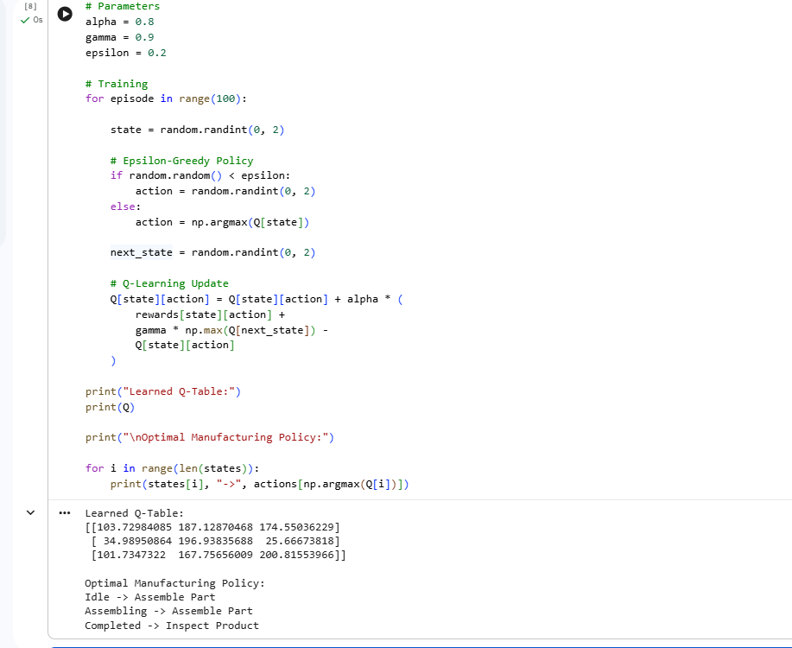

9. An online advertising system uses Reinforcement Learning to maximize click-through rates. Outline reward design challenges and explain their impact on system performance. (5 Marks)

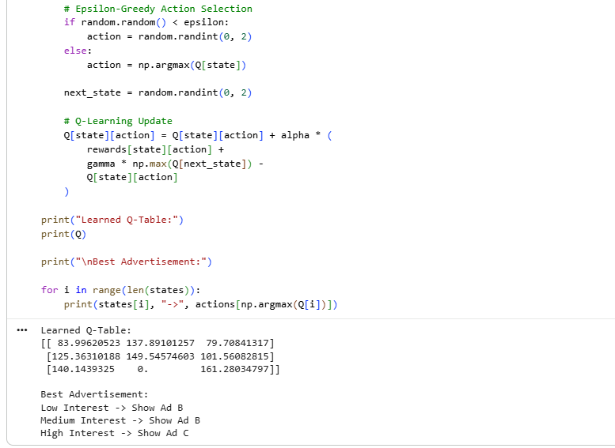
10. A smart irrigation system uses Reinforcement Learning to optimize water usage. Create an RL framework by defining states, actions, and reward function. (5 Marks)

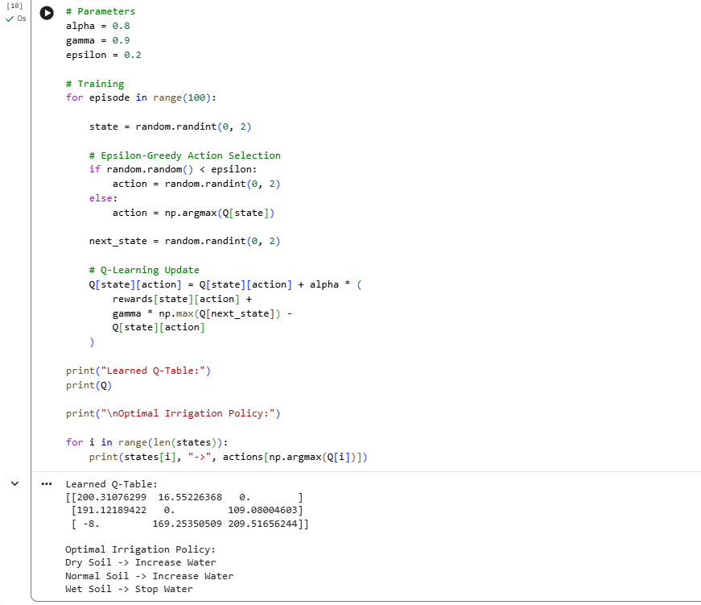

Code of Conduct:

I ____M.Samanvi(192425318)_____ (Name / Reg No) certify that this submission is my original work and that I have adhered to the guidelines specified for this assessment.
I understand that any violation of academic integrity rules will result in disciplinary action.

Signature of the student: M.Samanvi

RUBRICS FOR CALCULATION

Criteria | Weightage | Level 4 – Exemplary | Level 3 – Proficient | Level 2 – Developing | Level 1 – Beginning
Understanding of Problem Context | 20 | Clearly understands the problem and accurately identifies all requirements | Good understanding with minor gaps | Basic understanding; some requirements unclear | Poor understanding or misinterpretation of the problem
Application of Concepts | 30 | Accurately applies appropriate concepts to solve complex problems | Applies relevant concepts correctly with minor errors | Applies basic concepts with limited accuracy | Fails to apply appropriate concepts
Problem-Solving Approach | 20 | Logical, well-structured, and efficient approach | Mostly logical approach with minor gaps | Basic approach with some inconsistencies | Illogical or unclear approach
Accuracy of Solution | 20 | Completely correct solution with proper justification | Mostly correct with minor errors | Partially correct solution | Incorrect or incomplete solution
Clarity | 10 | Clear, well-organized, and properly explained solution | Understandable with minor clarity issues | Limited clarity and explanation | Poorly presented and difficult to understand

